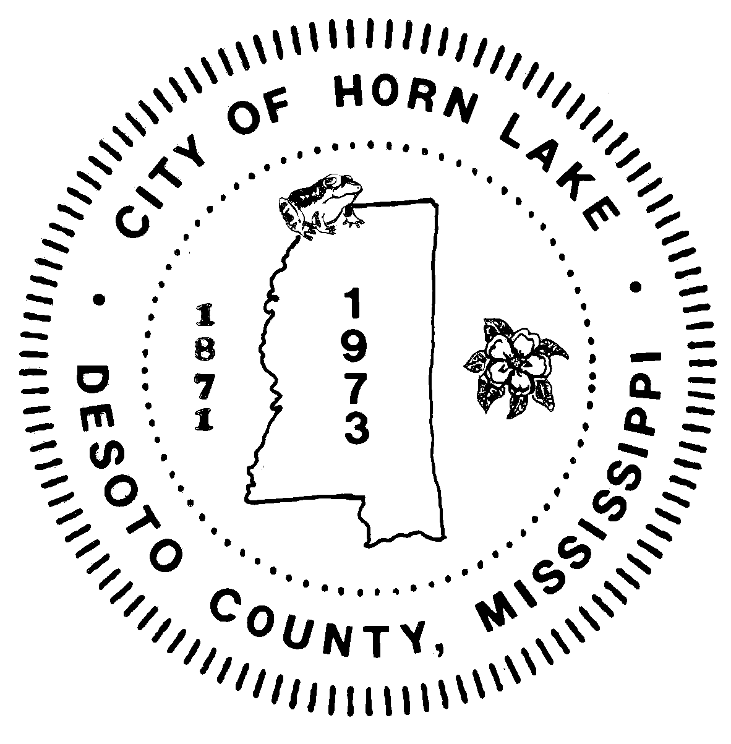
City of
Horn Lake Mayor: Allen Latimer

3101 Goodman Road West
Horn Lake, MS 38637
Phone: 662-393-6178

April 27, 2020

My fellow citizens of Horn Lake:

The citizens and businesses of Horn Lake have made many sacrifices and exhibited much patience in our battle against the COVID-19 virus. By working together, you have made it possible for us to reopen some of our businesses on a phased schedule. This will allow us to begin the process of living normal lives once again. The struggle against this virus is not over yet, and we must continue our efforts to overcome its spread in order to protect our public and individual health. Governor Reeves has issued Executive Order #1477 to begin this recovery process. This Executive Order can be found on your city website at HornLake.org. Please review it for your benefit. Additionally, there is a list of frequently asked questions to answer many questions you may have. If you need further information, please contact your City Hall.

The City recommends you follow all CDC guidelines, frequently wash your hands, and wear a facial covering for your nose and mouth. We further encourage that those who face a higher risk due to underlying health problems continue to use all safeguard measures.

Respectfully,

Allen B. Latimer, Mayor
Horn Lake, Mississippi

